DBMS Assignment-2

1. Check the serilaizability of the following schedules using precedence graph/ label precedence graph as per the question.

a) R2(X), W3(X), W1(X), W2(Y), R4(X), R4(Y), for conflict serializability.

b) R1(X); W1(X); R3(X); R2(X); W3(X), for view serializability.

2. Check whether the given schedules are conflict serializable or not using precedence graph. a) R4(X), R2(X), R3(X), W1(Y), W2(X), R3(Y), W2(Y)

b) R1(X), R2(Z), R1(Z), R3(X), R3(Y), W1(X), W3(Y), R2(Y), W2(Z), W2(Y)

3. Concurrency control helps in managing simultaneous operations without conflicting with each another. In relation to this, discuss with example the following problems that may be encountered during concurrency execution of transactions:

a) Lost update problem

b) Dirty read problem.

4. Let R = (A, B, C) be a given relation schema with functional dependencies, F = {A→ BC, B → C, A → B, AB→C}.

Find the canonical cover of F. Show the intermediate steps of your derivation.

5. Let R = (A, B, C, D) be a given relation schema with functional dependencies, F = {AB → C, C → B, C → D}.

a) Find candidate keys, prime attributes and non prime attributes of R.

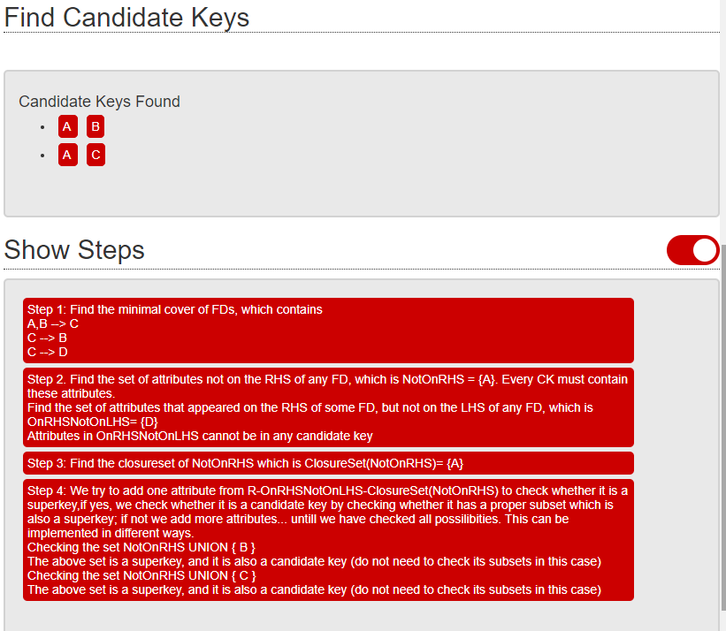

b) Is R in 3 NF or in BCNF? Justify. If not then normalize R.

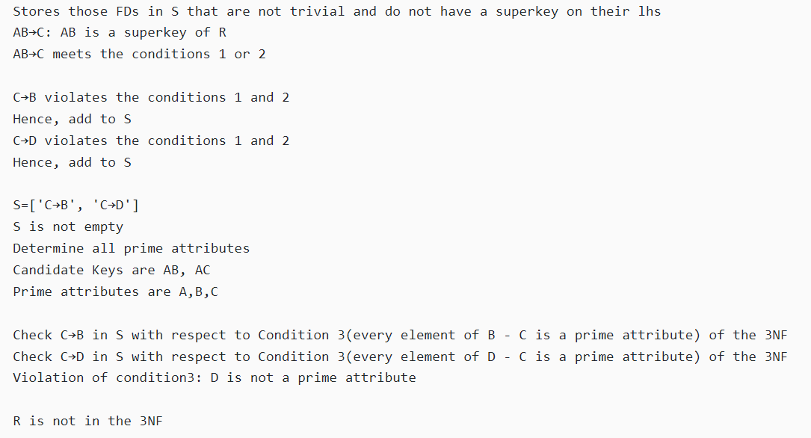

6. Consider the relation schema R (A, B, C, D, E) and the set F={AB->CE, E->AB, C->D}. What is the highest normal form of this relation?

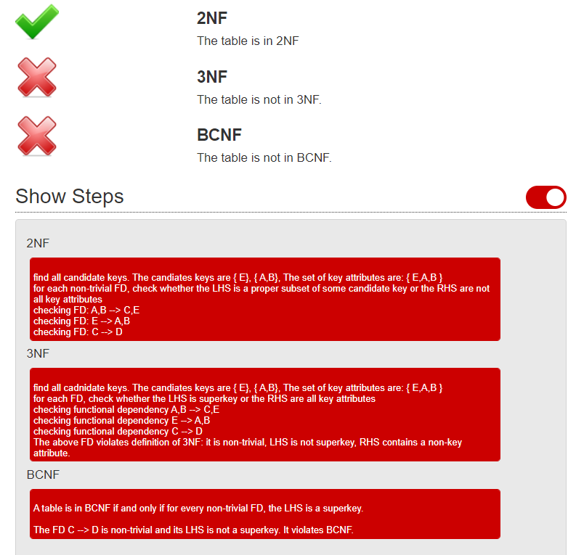

7. Difference between 4NF and 5NF with example.